AM000-Asia-China-Warring States-28 Lunar Lodges-8 Hexagrams-4 Zodiac Animals-475-221 BCE

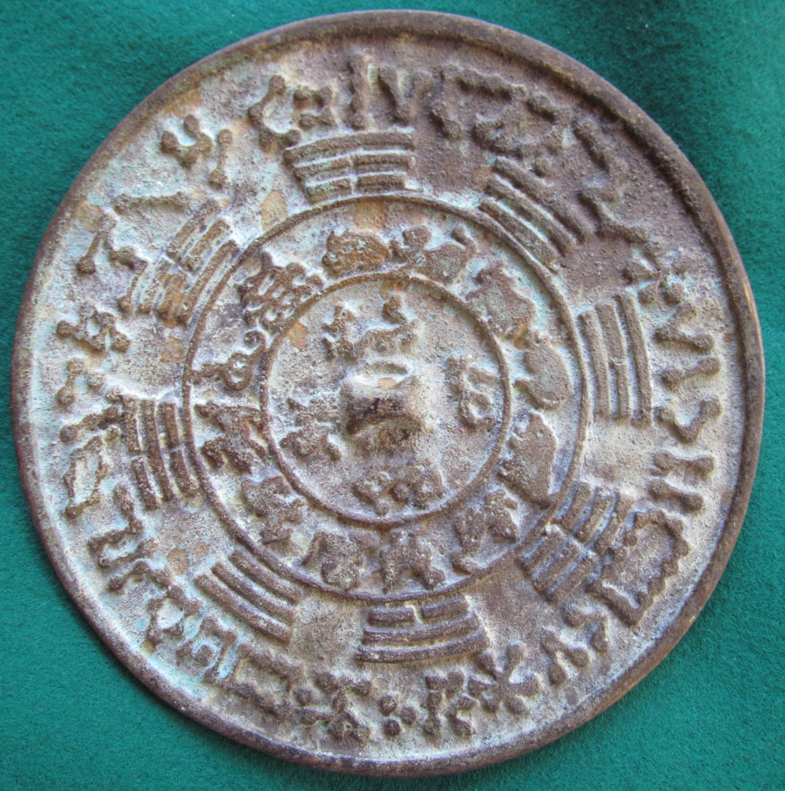

This unusual mirror is a concordance of the 28 lunar lodges, the 8 hexagrams, the 12 zodiacal animals and the animals of the 4 directions.